Ex.No 7 Create simple application like wordcount using hadoop

Aim
To create simple application like word count using hadoop.
Softwares Required
- hadoop
- eclipse
- hadoop jar files
Word count
Hadoop MapReduce is a software framework for easily writing applications which process vast amounts of data (multi-terabyte data-sets) in-parallel on large clusters (thousands of nodes) of commodity hardware in a reliable, fault-tolerant manner.
A MapReduce job usually splits the input data-set into independent chunks which are processed by the map tasks in a completely parallel manner. The framework sorts the outputs of the maps, which are then input to the reduce tasks. Typically both the input and the output of the job are stored in a file-system. The framework takes care of scheduling tasks, monitoring them and re-executes the failed tasks.
WordCount is a simple application that counts the number of occurrences of each word in a given input set.
Program
import java.io.IOException;
import java.util.StringTokenizer;
import org.apache.hadoop.conf.Configuration;
import org.apache.hadoop.fs.Path;
import org.apache.hadoop.io.IntWritable;
import org.apache.hadoop.io.Text;
import org.apache.hadoop.mapreduce.Job;
import org.apache.hadoop.mapreduce.Mapper;
import org.apache.hadoop.mapreduce.Reducer;
import org.apache.hadoop.mapreduce.lib.input.FileInputFormat;
import org.apache.hadoop.mapreduce.lib.output.FileOutputFormat;

public class wordcount {

public static class TokenizerMapper
extends Mapper<Object, Text, Text, IntWritable>{

private final static IntWritable one = new IntWritable(1);
private Text word = new Text();

public void map(Object key, Text value, Context context
) throws IOException, InterruptedException {
StringTokenizer itr = new StringTokenizer(value.toString());
while (itr.hasMoreTokens()) {
word.set(itr.nextToken());
context.write(word, one);
}
}
}

public static class IntSumReducer
extends Reducer<Text,IntWritable,Text,IntWritable> {
private IntWritable result = new IntWritable();

public void reduce(Text key, Iterable<IntWritable> values,
Context context
) throws IOException, InterruptedException {
int sum = 0;
for (IntWritable val : values) {
sum += val.get();
}
result.set(sum);
context.write(key, result);
}
}

public static void main(String[] args) throws Exception {
Configuration conf = new Configuration();
Job job = Job.getInstance(conf, "word count");
job.setJarByClass(wordcount.class);
job.setMapperClass(TokenizerMapper.class);
job.setCombinerClass(IntSumReducer.class);
job.setReducerClass(IntSumReducer.class);
job.setOutputKeyClass(Text.class);
job.setOutputValueClass(IntWritable.class);
FileInputFormat.addInputPath(job, new Path(args[0]));
FileOutputFormat.setOutputPath(job, new Path(args[1]));
System.exit(job.waitForCompletion(true) ? 0 : 1);
}
}

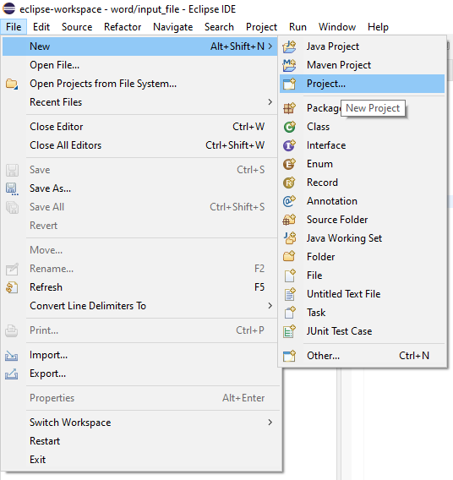
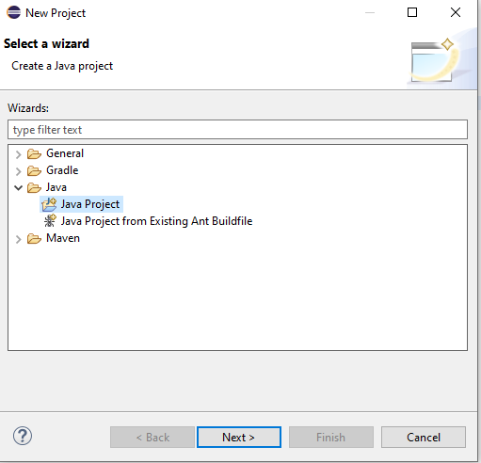
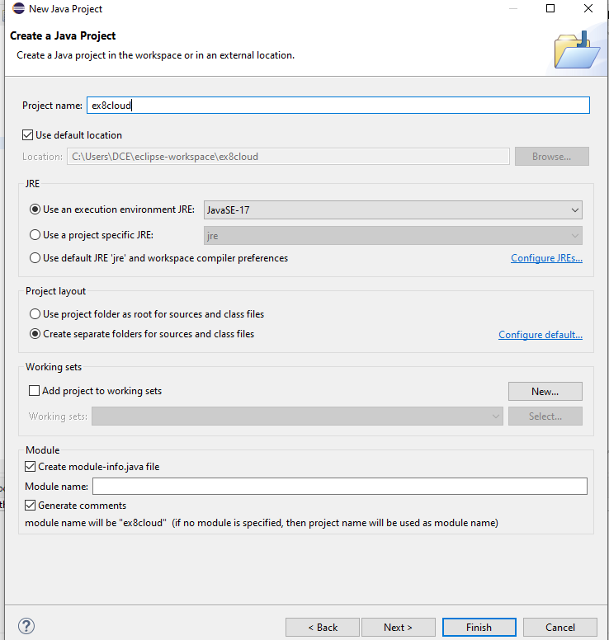
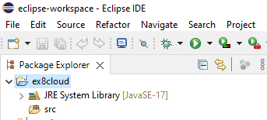
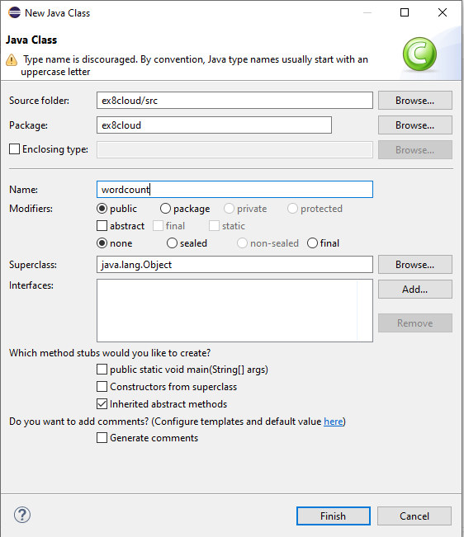
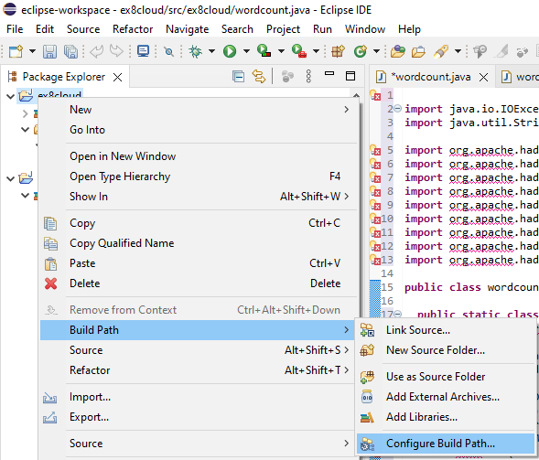

https://github.com/jijim/HADOOP-Windows10/blob/master/Eclipse_JAR_Imports_Final.rar

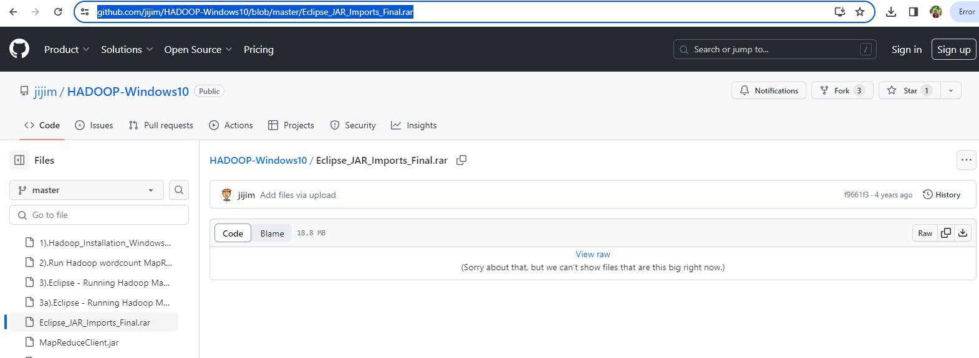
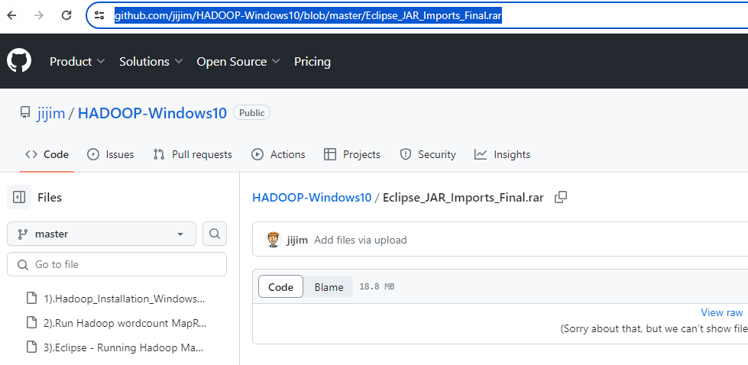


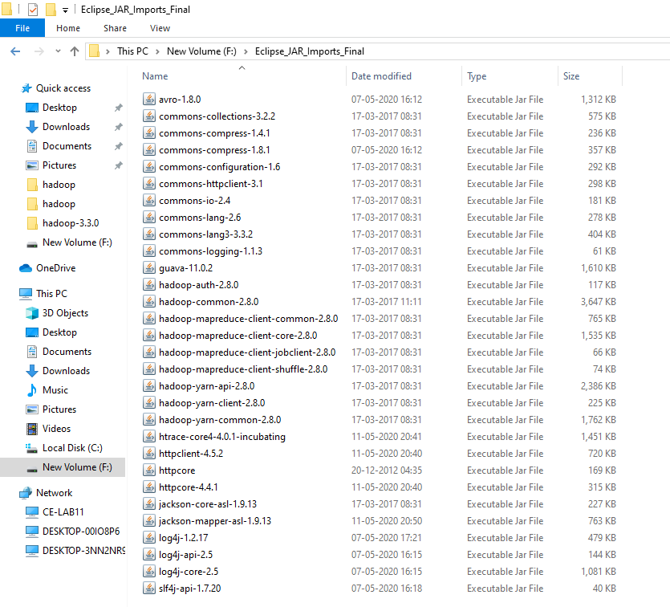
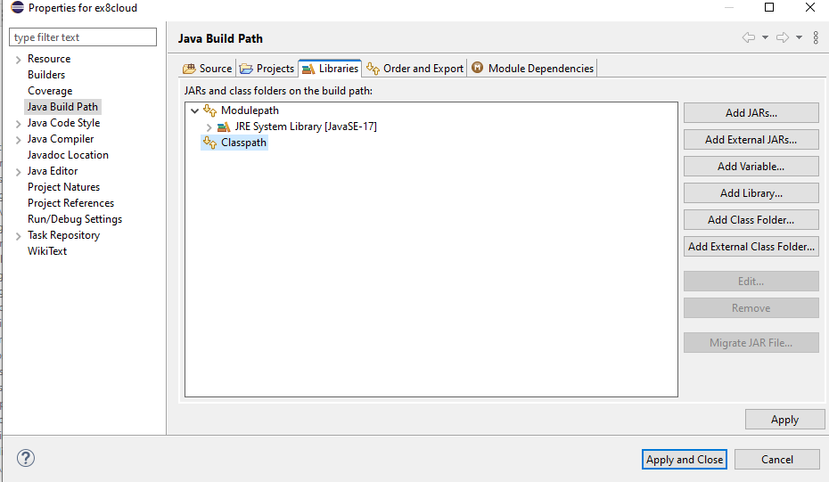
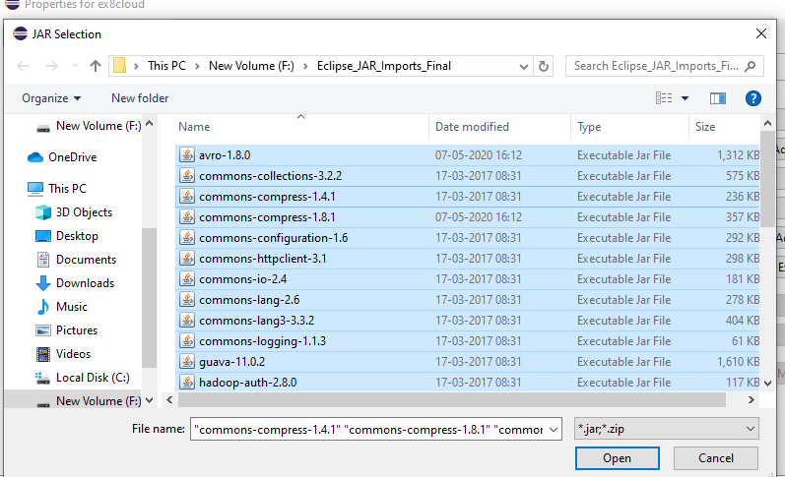
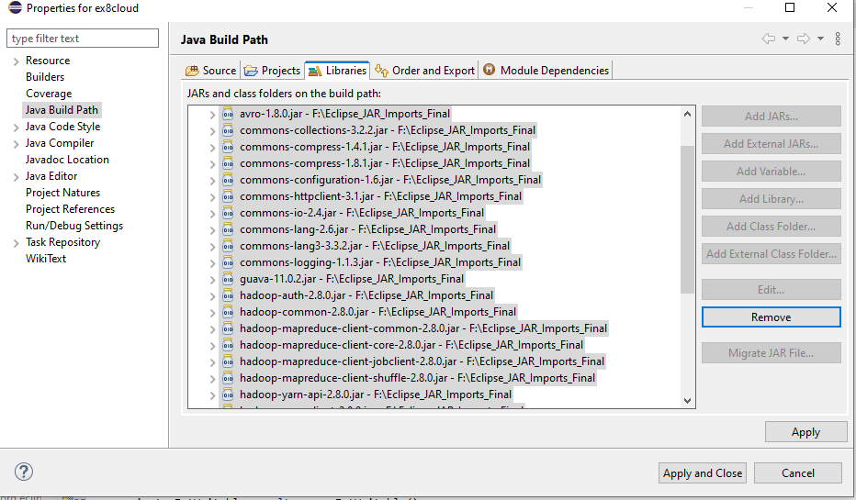
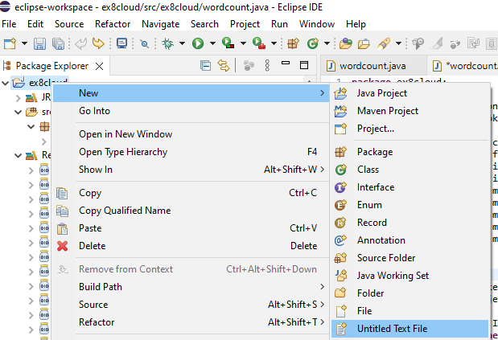
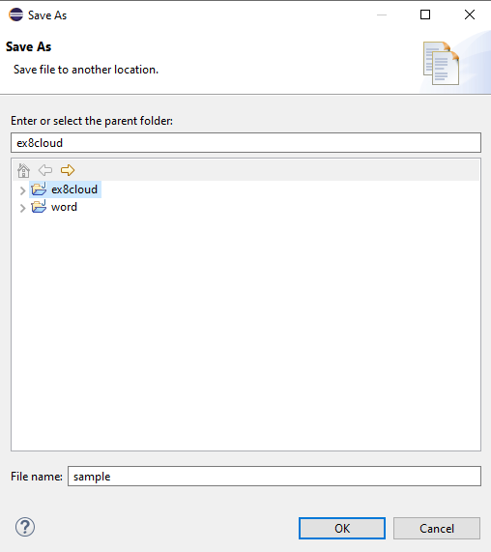
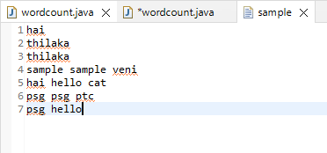
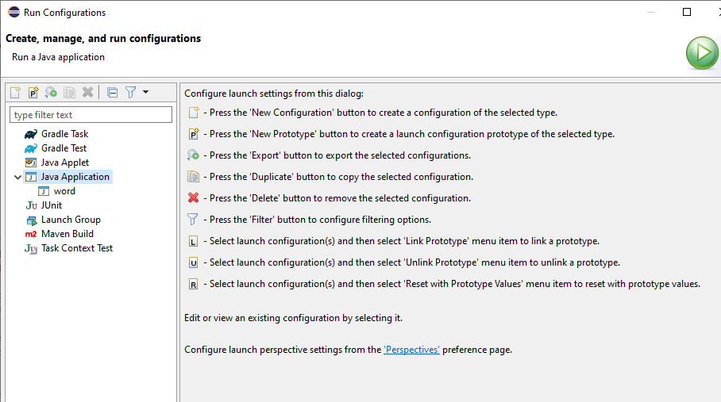

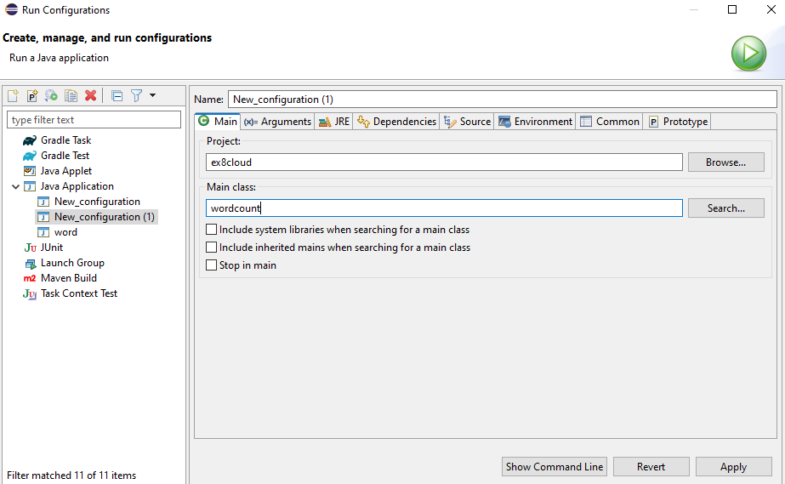

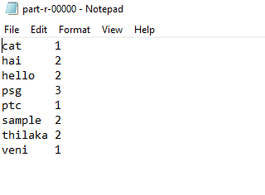

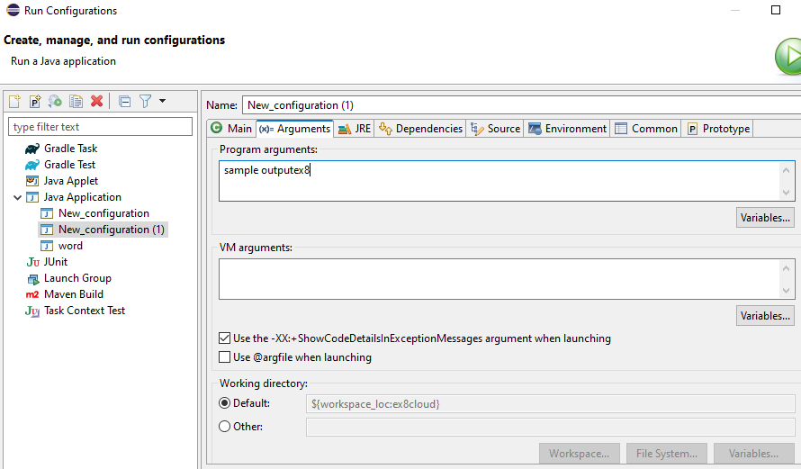

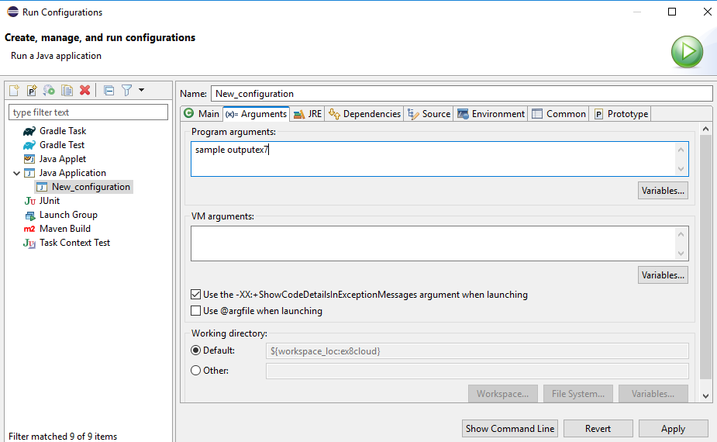
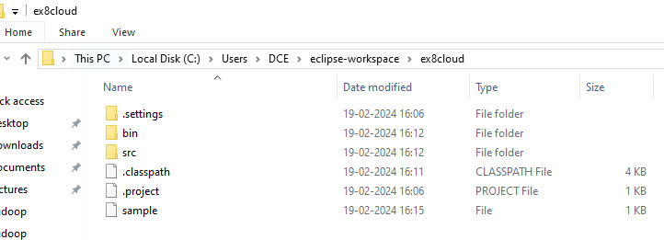

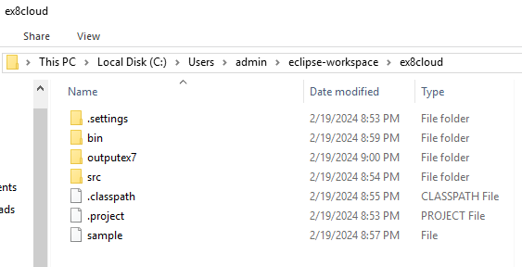
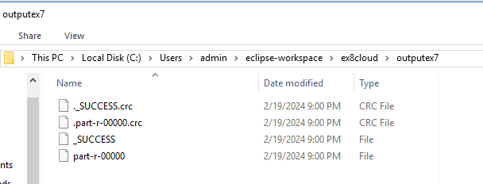

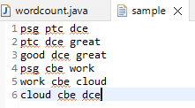
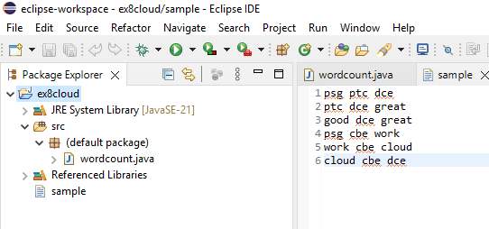
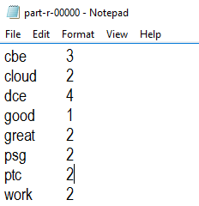

Result
Thus the application like word count was created using hadoop.

